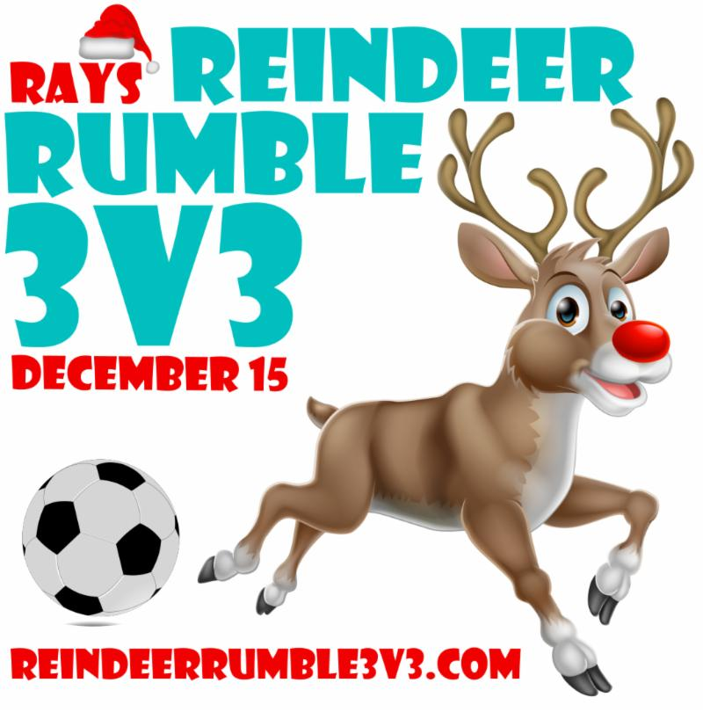
Saturday, December 15th
Jonesville Soccer Park
Gainesville, FL
https://reindeerrumble3v3.com/
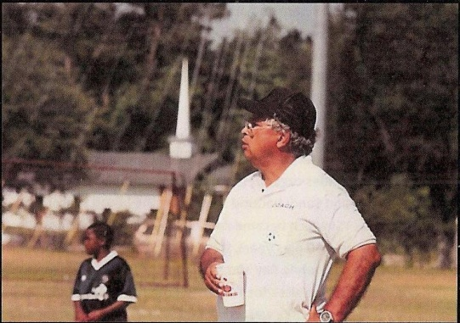
Ray Rivera - Coach and Mentor - 1937-2016
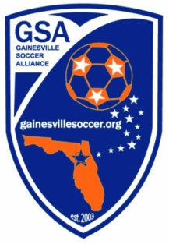
The Gainesville Soccer Alliance and the Best Restoration are proud to announce that we will be hosting a 3v3 tournament called the Ray Rivera’s Reindeer Rumble at Jonesville Park on Saturday, December 15th!

3v3's are great events, with fast paced small sided action where all of the players get a ton of touches on the ball. It's extremely affordable as well, at just $120 per team. We will offer multiple divisions (both travel and recreational), and have the flexibility to move teams around to help create evenly matched, competitive groups.

We hope all of our competitive teams, Academy teams, and YSI@GSA teams help spread the word and encourage their players to come out and join in on the fun!

3v3 teams can have anywhere from 4 to 6 players. The team's age group will be determined by the age of the oldest player on the roster. The players do not have to be members of GSA, or even carded with FYSA.

To apply, simply fill out a registration form and turn it in with the $120 entry fee to the concession stand (or mail it to the address on the application). The roster form has a waiver that will need a signature from every player's parent. These will be turned in at check in at team check-in on the 15th.
Questions: Email Tournament Director: Alan Womack at gsageneralmanager@yahoo.com

